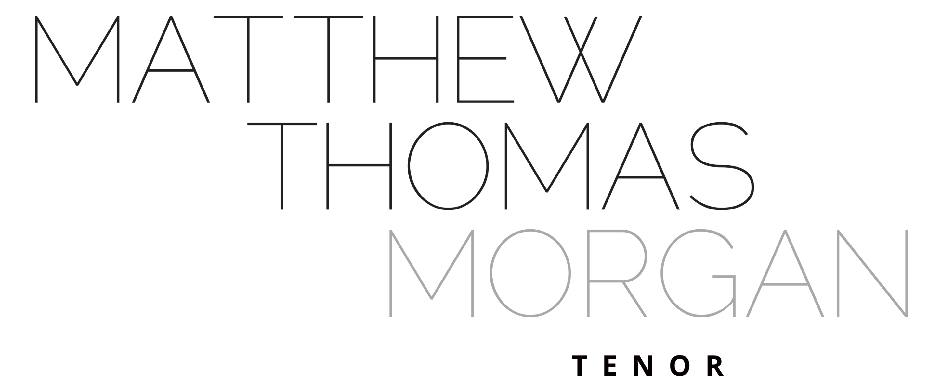
MATTHEW THOMAS MORGAN - Biography
June 2024 (Full Version)

Matthew Thomas Morgan was born in Bexley, South-East London. His interest in vocal study began at Eltham College under the tutorship of Timothy Penrose. Matthew completed his time in higher education in 2015 where he studied consecutively at the Durham University, the Royal Academy of Music (RAM) and the Royal Conservatoire of Scotland (RCS). Matthew has been fortunate to study with, amongst others, Neil Mackie CBE and Iain Paton and David Barrell.

Matthew has had a varied career as a tenor and has enjoyed working on the concert stage and in opera. Highlights include his stints as an Alvarez Young Artist at Garsington Opera in 2013, 2016 & 2017 and his work for a wide range of UK choral societies. Matthew was a choral scholar at both Durham and Portsmouth Cathedrals (2007 – 2011) during his years of study.

On the conducting podium he has performed at Cadogan Hall as part of the Grenfell Tower Benefit Concert (in addition to being a vocal soloist) In 2020, he was Artistic Director (and soloist) in ‘Opera by the Lake’ at Van Mildert College, Durham University, where he had the pleasure to work with Sir Thomas Allen, the culmination of a year’s work as Arts & Community Outreach Fellow at the college. In 2022, Matthew was appointed as Musical Director (Classical) of the Addison Singers in London a post he took up in 2023. He was Musical Director of Parenthesis Choir, Reading between 2016 – 2020, and was the first Assistant Conductor to the Hastings Philarmonic Choir & Orchestra. In the summer of 2017, he conducted Armide by Lully with Ensemble OrQuestra at the Grimeborn Festival at London’s Arcola Theatre. He acted as interim Musical Director for A-CHORD choir in Finchley during the Spring of 2019 and has held two Junior Fellowships in colleges at Durham University. Matthew was ‘Musician in Residence’ in 2018 at St. Cuthbert’s Society. Matthew was elected to be an Associate Fellow at Van Mildert College in February 2020 in recognition of his outstanding contribution to the artistic life in college. Matthew was Director of Music at St. Mary’s College, Durham University and as Chorus Master for the Durham University Music Society during his time as an undergraduate.

Matthew has wide ranging musical interests has worked extensively with various colleges at Durham University, teaching choirs, providing masterclasses and advising on musical provision for students. During the COVID 19 pandemic Matthew designed and retailed freestanding Perspex screening for musicians, SingScreen, and these units featured in opera houses, with leading vocal ensembles and on UK media. Matthew was appointed as a Licensed Vocal Teacher for Bromley Youth Music Trust in 2021 and works with students at four schools across the borough. Matthew has previously been supported by the RCS Trust and the Josaphine Baker Trust.

www.matthewthomasmorgan.co.uk
www.bromleyvocalstudio.co.uk

(Word Count: 480)
……………………………….
M. Morgan
26.x.24

