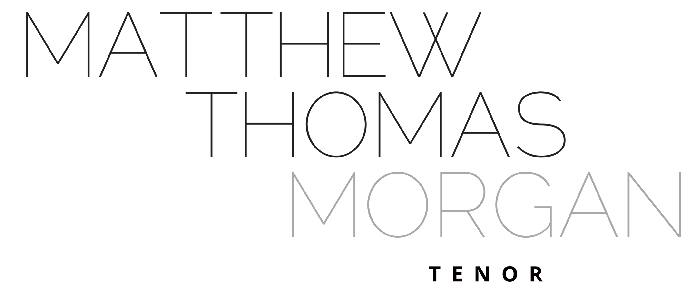
MATTHEW THOMAS MORGAN - Biography
October 2024 (Short Version)

Matthew Morgan was born in Bexley. He graduated from the Royal Conservatoire of Scotland (RCS) having previously studied at the Royal Academy of Music and Durham University. Matthew has been fortunate enough to study with Neil Mackie CBE, and David Barrell. Matthew has regularly a soloist with various choral societies and opera productions in the south-east of England. He worked with Garsington Opera in 2013, 2016 & 2017 as an Alvarez Young Artist. Credits at the RCS included Basilio (Marriage of Figaro), Le journaliste (Mamelles de Tirésias) and Slender (Sir John in Love).

Matthew has wide ranging musical interests and worked extensively at Durham University teaching choirs, providing masterclasses and advising on musical provision for students. He is in high demand as a choir trainer and musical mentor across the UK. Matthew was appointed as Musical Director (Classical) of the Addison Singers in 2022 taking up the reigns in 2023. Previously, Matthew has been Musical Director or Assistant Conductor of Parenthesis Choir, Reading, Hastings Philharmonic Choir & Orchestra, Ensemble OrQuestra and A-CHORD choir in Finchley. Summer 2017 saw him conduct Armide by Lully with Ensemble OrQuestra at the Grimeborn Festival at London’s Arcola Theatre. The following September he conducted and sang at the Grenfell Tower Benefit Concert at Cadogan Hall, London. He was Musician in Residence at St. Cuthbert’s Society, Durham University in 2018 and in March 2020, completed his time as Arts & Community Outreach Fellow at Van Mildert College, Durham University, where he directed Opera by the Lake, with Sir Thomas Allen, both conducting and singing in the performance. He was elected to be an Associate Fellow at Van Mildert College in February 2020 in recognition of his outstanding contribution to the artistic life of college. During the COVID 19 pandemic Matthew designed and retailed freestanding Perspex screening for musicians, SingScreen, and these units featured in opera houses, with leading vocal ensembles and on UK media. Matthew is currently a Licensed Vocal Teacher for Bromley Youth Music Trust. Matthew has previously been supported by the RCS Trust and the Josaphine Baker Trust.

www.matthewthomasmorgan.co.uk
www.bromleyvocalstudio.co.uk

……………………………….
M. Morgan
26.x.24

(Word Count: 362)

